Fill In the Blanks in Spreadsheets the Easy Way
1. Select all the rows in your Microsoft Office Excel spreadsheet data set.
2. On the Home tab, in the Editing section, click Find & Select, click Go To, click Special, click Blanks, and then click OK.
3. Click the equal sign (=) on the toolbar, select the cell above, and then hold down the CTRL key while you press ENTER. Blanks in the spreadsheet will be filled automatically.
4. Copy all the data, click Paste Special, and then click Values. This will overwrite the formulas and enable you to sort the data by filling in each empty cell with the same information as the one above. This tip will work on any size of data set.

Tip 1: Add a Get Started tab to the Ribbon
In Excel 2007, toolbars and menus no longer appear along the top of the window. Instead, you'll see the Ribbon, which is part of Microsoft Office Fluent user interface. When you first start using Excel 2007, you'll probably have questions about where to find Excel 2003 commands and toolbar buttons. To help answer those questions, I recommend that you download a free add-in that adds a Get Started tab to the Ribbon.
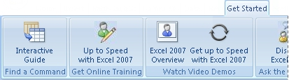
You can use the commands on this tab to get to training courses, video demos, newsgroups, and other content designed to help you learn Excel 2007. The most useful tool for those who are new to the Ribbon is the Interactive Guide (the button on the far left), which shows you exactly where to find Excel 2003 buttons and commands in Excel 2007. Trust me, it's a lifesaver.
You can download the Get Started Tab for Excel 2007 from the Microsoft Download Center. If you don't want to add the Get Started tab to Excel 2007, or if your company prohibits you from downloading the add-in, you can access the Excel 2003 to Excel 2007 command reference guide directly.
Top of Page

Tip 2: Take advantage of the Quick Access Toolbar
Some of your favorite commands may not appear on the Ribbon by default. Although you can't add commands to the Home, Insert, or other Ribbon tabs, you can customize the Quick Access Toolbar, which appears by default above the Ribbon.
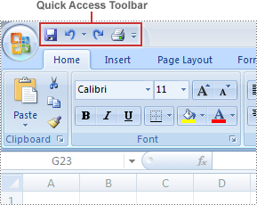
To add a new command to the Quick Access Toolbar, click the arrow next to the Quick Access Toolbar, and then click More Commands.
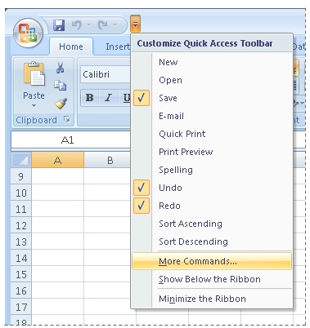
At this point, the Excel Options dialog box appears. In the Choose commands from box, click Commands Not in the Ribbon to view the commands that didn't make it onto the Ribbon.
Here are the commands I added to my Quick Access Toolbar.
Command | Description
The Print Preview button | Print Preview still exists in Excel 2007, of course, but it isn't as visible as it was in Excel 2003. To bring the Print Preview button back to the forefront, I added it to my Quick Access Toolbar. You can do that, too, or you can simply memorize the keyboard shortcut for Print Preview, which is CTRL+F2.
The Form button | Many of you are frustrated by the fact that the Form button, which is the entry point to the data form feature, is not on the Ribbon. To refresh your memory, a data form is a dialog box in which you can enter or view one complete row of information in a range or table. It looks something like this:  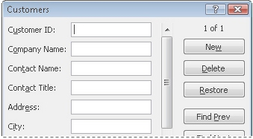  If you use data forms a lot, then by all means, add the Form button to the Quick Access Toolbar.
The Document Location box | Oh, how I love the Document Location box, which displays the path and file name for my workbook. I can't tell you how often I end up copying the information in this box and sending it to colleagues.  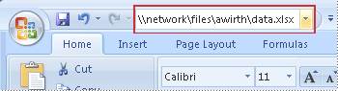  Okay, so this box never appeared on the toolbars by default in Excel 2003 either. No matter. You should add it if you want to see or copy the full path and file name for your workbook.
The Send to Mail Recipient command | From reading your comments, it's apparent that you miss the Send to Mail Recipient command as much as I do. This command lets you quickly send a selection of cells in a workbook in the body of an e-mail message.
I should point out here that you can add any command you want to the Quick Access Toolbar, even ones that are already on the Ribbon. For example, if you want the Filter command to be visible at all times, open the Data tab and right-click the Filter button. When the shortcut menu appears, click Add to Quick Access Toolbar.
Top of Page

Tip 3: Minimize the Ribbon, maximize your workspace
This one is short and sweet. If you want more room to work, press CTRL+F1 to go from this:
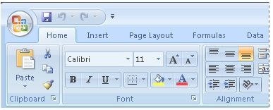
To this:
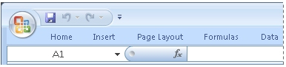
Press CTRL+F1 again to maximize the Ribbon.
Top of Page

Tip 4: Choose your own default font
In Excel 2003, the default font was trusty Times New Roman. In Excel 2007, the defaults have changed. The font that appears in cells, headers or footers, and text boxes is known in Excel 2007 as the body font.
When you install Excel 2007, the body font for all new workbooks is 11-point Calibri.
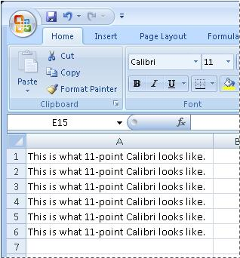
So what's a body font? Well, when you apply a new theme to your workbook, all text that is tagged with the body font changes automatically, without you having to do anything extra. For example, if you change the theme for your workbook from Office to Apex, all text changes from Calibri to Book Antiqua.
If you want, you can use a different font instead of the body font. So, for example, you can choose to use 10-point Arial for all workbooks instead of the default body font. Know that if you do this, however, you lose the ability to easily swap fonts wholesale when you change the theme for a workbook, since themes rely on text being tagged with the "body font" designator. In other words, if you specify Arial as your default font for all new workbooks, that font won't change automatically in response to you applying a theme. If you're okay with that, go ahead and change the default font to whatever works for you.
To change the default font, click the Microsoft Office Button , and then click Excel Options. In the Popular category, look for the following settings:
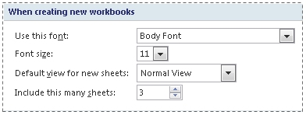
In the Use this font and Font size boxes, click the font and font size that you want to use. To begin using the new default font, you need to restart Excel.
Top of Page

Tip 5: Restore missing worksheet tabs
I've seen many, many comments indicating that the tabs at the bottom of your worksheets are disappearing into thin air:
- “Please tell me how to hide/unhide the sheet tabs! Please I'm begging!” “There are no worksheets hidden, but I can't see them, don't know why. There should be 5 of them there, I can't see the tabs, only the first sheet is shown but also without sheet tab. HELLLLP!!!”
This has happened to me before, and it's annoying. The problem generally occurs when you've used the Restore Window button to unhook your workbook window from the Excel window, and then sized the workbook window in such a way that the tabs disappear behind the status bar.
To recover your worksheet tabs, double-click the title bar of your workbook. This action maximizes the window and returns the tabs to their proper spot on the screen.
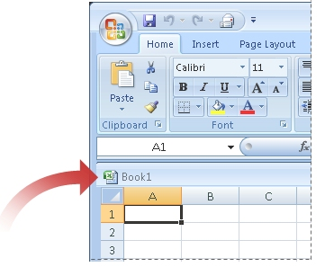
If this doesn't do the trick, let me know by responding to the Was this information helpful? question at the bottom of this column.
Top of Page

Tip 6: Freeze panes here, there, and everywhere
When you freeze panes in your workbook, you “lock” specific columns, rows, or both so that they remain visible as you scroll around in your workbook. If you work with large amounts of data, you no doubt recognize the value of this feature. However, judging by your comments, you think we've removed the ability to freeze anything but the top row or left column:
- “I want to freeze the second row in a worksheet that has my titles in it. However, it will only freeze the top row. How can I freeze the second row?”
- “Why the heck did you change the functionality of Freeze Pane? I want to freeze my first column and my top row."
Don't panic. We haven't removed this functionality! It's all still there on the View tab, in the Window group.
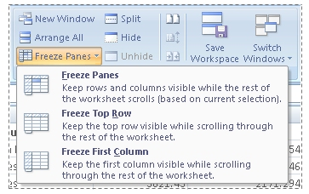
To freeze a specific range of rows and columns, select a cell immediately below and to the right of the rows and columns that you want to freeze. Then, on the View tab, in the Windows group, click Freeze Panes to open the menu. Click Freeze Panes, and everything above and to the left of the cell you selected will stay in place when you scroll in the worksheet.
To freeze more than just the top row, click the row immediately below the last row you want to freeze. For example, to freeze rows 1, 2, and 3, click row 4, and then click Freeze Panes on the menu.
To freeze more than just the first column, click the column immediately to the right of the last column you want to freeze. For example, to freeze columns A, B, and C, click column D, and then click Freeze Panes on the menu.

1. Becoming familiar with the new user interface
One of the first things you’ll notice about Office Excel 2007 is that the user interface has changed quite a bit. Earlier versions of Office Excel housed the program’s more than 1,000 commands in a series of menus, toolbars, task panes, and dialog boxes. And, as it turns out, there were some functions that didn’t appear by default on any of the menus or toolbars. In Office Excel 2007, there is only one place to look for the tools you need to use it: the user interface Ribbon at the top of the program window. The Office Excel 2007 product team took the dozens of menus and toolbars and reorganized their contents onto the Ribbon tabs and galleries. If you’ve used Excel before, you’ll need to spend only a little bit of time working with the new user interface to bring yourself back up to your usual proficiency. If you’re new to Excel, you’ll have a much easier time learning to use the program than you would have had with the previous user interface.
Unlike in previous versions of Excel, which made you hunt through a complex toolbar and menu system to find the commands you wanted, you can find everything you need at the top of the Office Excel 2007 program window. The Office Excel 2007 user interface divides its commands into seven tabs: Home, Insert, Page Layout, Formulas, Data, Review, and View. The Home tab appears when you start Office Excel 2007.
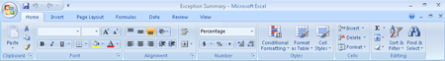
Top of Page

2. Managing larger data collections
Many Excel users take advantage of the program’s data summary and calculation capabilities to process large data collections. In Office Excel 2003 and earlier versions, you were limited to 65,536 rows and 256 columns of data in a worksheet. You could always spread larger data collections across multiple worksheets, but it took a lot of effort to make everything work correctly. You don’t have that problem in Office Excel 2007. The Office Excel 2007 product team expanded worksheets to include 16,384 columns and 1,048,576 rows of data, which should be sufficient for most of the projects you want to do in Office Excel 2007.
Office Excel 2007 also comes with more powerful and flexible techniques you can use to process your worksheet data. In Office Excel 2003, you could assign up to three conditional formats (rules that govern how Excel displays a value) to a cell. In Office Excel 2007, the only limit on the number of conditional formats you can create is your computer’s memory.
Top of Page

3. Using the new Microsoft Office file format
Starting with Microsoft Office 97 release, all Microsoft Office programs used a binary file format that computers (but not humans) can read. Office Excel 2007, Microsoft Office Word 2007, and Microsoft Office PowerPoint 2007 have a new and improved file format that, in addition to being somewhat readable, creates much smaller files than the older binary format.
The new Office Open XML Formats combine the XML and the Zip file compression format to create robust files that (on average) are about half the size of similar Excel 97–2003 files. You can open and save Excel 97–2003 files in Office Excel 2007, of course. If you want to open Office Excel 2007 files in Excel 2000, Excel 2002, or Office Excel 2003, you can install the Microsoft Office Compatibility Pack for Office Word 2007, Office Excel 2007, and Office PowerPoint 2007 file formats from this book’s companion CD.
Besides smaller file sizes, the 2007 Microsoft Office system file formats offer several other advantages:
- Improved interoperability
- Enhanced customization
- Improved automation
- Compartmentalizing information
Top of Page

4. Formatting cells and worksheets
Excel has always been a great program for analyzing numerical data, but even Office Excel 2003 came up a bit short in the presentation department. Office Excel 2007 offers vast improvements over the color management and formatting options found in previous versions of the program. You can have as many different colors in a workbook as you like, for example, and you can assign a design theme to a workbook. Assigning a theme to a workbook offers you color choices that are part of a complementary whole, not just a dialog box with no guidance about which colors to choose. You can, of course, still select any color you want when you format your worksheet, define custom cell styles, and create your own themes. The preinstalled themes are there as guides, not prescriptions.
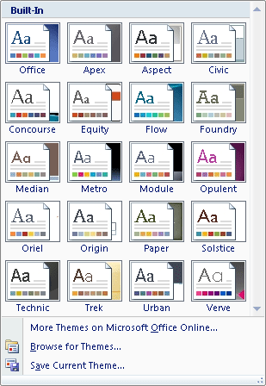
Top of Page

5. Managing data tables more effectively
You’ll often discover that it makes sense to arrange your Office Excel 2007 data as a table, in which each column contains a specific data element (such as an order number or the hours you worked on a given day), and each row contains data about a specific business object (such as the details of delivery number 1403). In Office Excel 2007, tables enable you to enter and summarize your data efficiently. If you want to enter data in a new table row, all you have to do is type the data in the row below the table. After you press Tab or Enter after typing in the last cell’s values, Office Excel 2007 expands the table to include your new data. You can also have Office Excel 2007 display a Totals row, which summarizes your table’s data using a function you specify.
Top of Page

6. Creating formulas more easily by using formula AutoComplete
Office Excel 2003 and earlier versions of the program provided two methods to find the name of a function to add to a formula: the help system and the Insert Function dialog box. Office Excel 2007 adds a new tool to your arsenal: Formula AutoComplete. Here’s how it works: When you begin typing a formula into a cell, Office Excel 2007 examines what you’re typing and then displays a list of functions and function arguments, such as named cell ranges or table columns that could be used in the formula. Formula AutoComplete offers lists of the following items as you create a formula:
- Office Excel 2007 functions
- User-defined functions
- Formula arguments
- Defined names
- Table structure references
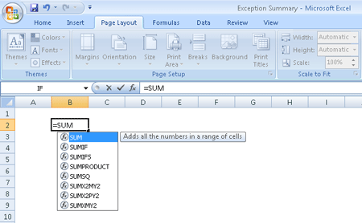
Top of Page

7. Summarizing data using new functions
The Office Excel 2007 programming team encourages users to suggest new capabilities that might be included in the future versions of the program. One of the most common requests from corporations using Excel was to find the average value of cells where the value met certain criteria. For example, in a table summarizing daily sales by department, a formula could summarize sales in the Housewares department for days in which the sales total was more than $10,000.
The Office Excel 2007 team responded to those requests by creating five new formulas that enable you to summarize worksheet data that meets a given condition. Here are quick descriptions of the new functions and any existing functions to which they’re related:
- AVERAGEIF enables you to find the average value of cells in a range for cells that meet a single criterion.
- AVERAGEIFS enables you to find the average value of cells in a range for cells that meet multiple criteria.
- SUMIFS, an extension of the SUMIF function, enables you to find the average value of cells in a range for cells that meet multiple criteria.
- COUNTIFS, an extension of the COUNTIF function, enables you to count the number of cells in a range that meet multiple criteria.
- IFERROR, an extension of the IF function, enables you to tell Excel 2007 what to do in case a cell’s formula generates an error (as well as what to do if the formula works the way it’s supposed to).
Top of Page

8. Creating powerful conditional formats
Businesses often use Excel to track corporate spending and revenue. The actual figures are very important, of course, but it’s also useful for managers to be able to glance at their data and determine whether the data exceeds expectations, falls within an acceptable range, or requires attention because the value falls below expectations. In versions prior to Office Excel 2007, you could create three conditions and define a format for each one.
In Office Excel 2007, you can have as many rules as you like, apply several rules to a single data value, choose to stop evaluating rules after a particular rule has been applied, and change the order in which the rules are evaluated without having to delete and re-create the rules you change. You can also apply several new types of conditional data formats: data bars, which create a horizontal bar across a cell to indicate how large the value is; color gradients, which change a cell’s fill color to indicate how large the value is; and icon sets, which display one of three icons depending on the guidelines you establish.
Top of Page

9. Creating more attractive charts
Office Excel 2007 enables you to manage large amounts of numerical data effectively, but humans generally have a hard time determining patterns from that data if all they have to look at are the raw numbers. That’s where charts come in. Charts summarize your data visually, which means that you and other decision-makers can quickly detect trends, determine high and low data points, and forecast future prospects using mathematical tools. The Excel charting engine and color palette haven’t changed significantly since Excel 97, but Office Excel 2007 marks a tremendous step forward with more ways to create attractive and informative charts quickly.
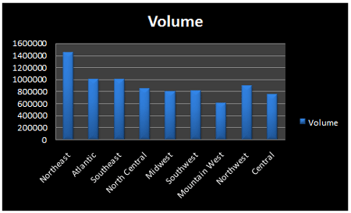
Top of Page

10. Controlling printouts more carefully
One of the Office Excel 2007 product group’s goals for Office Excel 2007 was to enable you to create great-looking documents. Of course, to create these documents, you must know what your documents will look like when you print them. The Microsoft Excel team introduced the Page Break Preview view in Excel 97; however it is somewhat limited from a printing control and layout perspective. In Office Excel 2007 when you display a workbook in Page Layout view, you see exactly what your work will look like on the printed page. The Page Layout view also enables you to change your workbook’s margins, add and edit headers and footers, and edit your data.

Enter a Fraction in a Cell
Microsoft Office Excel can display, and take data entry as, fractions as well as decimal numbers. To enter a fraction, simply prefix it with a zero and a space. So to display the fraction one-third, type 0 1/3. This will display 1/3 but will have an underlying value of 0.33333333.

Organize Colored Cells More Efficiently
When using the filter option for large Microsoft Office Excel worksheets in the 2007 Microsoft Office system, you can filter the document by color. Click the down-pointing filter arrow on your filtered column, and then click Filter by Color. The colors display as a list, from which you can select the color that you want to display.

Organize Your Records the Way You Want Them in Excel
You can customize how you sort your records by using a filter. To activate a filter:
1. In Microsoft Office Excel 2007, click Filter on the Data tab.

2. To choose your sorting options, click the filter arrow on the column that you want to sort, point to Sort by Color, and then click Custom Sort.

3. Create a customized sort order.
a. In the Sort dialog box, under Column, click the drop-down arrow next to Sort by, and choose the field that you want to be sorted. Values should appear in the Sort On field.
b. In the Order field, click Custom List. This will open a window that offers an entirely custom sort list.
c. In the left pane, list the values (each separated by a comma) in the order that you want them to be sorted, and then click Add.
d. In the right pane, select the list you've created, and then click OK.
e. In the Sort dialog box, click OK.
From now on, your records will be sorted according to your customized list.

Keep Important Documents Handy at All Times
When you click the Office button in the 2007 Microsoft Office system programs Word, Excel, or PowerPoint, you see a Recent Documents list, similar to that which appeared on the File menu in previous releases. However, in the 2007 release, you now see a pushpin icon next to each file name. Click that icon to pin the applicable document to the Recent Documents list so that it’s always accessible at a click. When you click the pushpin icon, it changes in appearance to show that the pin has been activated for that document.

Also note that you can change the number of recent documents that appear in the list. To do this, click the Office button, then click [Program] Options (for example, Word Options), and then click Advanced. Scroll down to the Display section, where you’ll see the option to change the number of recent documents displayed.

Freeze panes
Keep titles in sight as you scroll through worksheets. To freeze titles, make a selection in the worksheet, and then click Freeze Panes on the Windows menu. The secret to success is knowing how to select what you want to freeze:
- Column titles only Select the first row below the titles.
- Row titles only Select the first column to the right.
- Both column and row titles Select the cell that is both directly below the column titles and to the right of the row titles.
To unfreeze panes, on the Window menu, click Unfreeze Panes.
Tip You can freeze panes anywhere, not just below the first row or to the right of the first column. Click the row below, or the column to the right, or the cell that is both below and just to the right of whatever information you want to freeze.

Compare worksheets side by side
- If more than two workbooks are open, select the workbook you want to compare with in the Compare Side by Side box after you click the Compare Side by Side with command.
- To change sheets in both workbooks, you must click the sheet tabs in both workbooks. Clicking in one will not change the sheets in the other.
- You can see data up close by zooming in on both worksheets at the same time. Just click Zoom on the View menu.
- You can change the side by side orientation from horizontal to vertical by clicking Arrange on the Window menu, and then selecting Vertical. Be sure that you only have two workbooks open when you do this. If you have more than two, they'll all open up next to each other.
You only have to change orientation once. Excel will remember how you arrange your windows to compare them side by side. Clicking the Reset Window Position button on the Compare Side by Side toolbar will return the orientation to one on top of the other.
- If workbooks are differently sized or positioned—for example, if one is larger or smaller than the other—clicking the Reset Window Position button on the Compare Side by Side toolbar will return both workbooks to equal sizes and positions. Keep in mind, however, that this will also return orientation to one on top of the other if you previously set the orientation to one next to the other.

Use automatic sums
Excel automatically adds up numbers that you select, displaying the total in the status bar at the bottom of the window.
If you do not see the total in the status bar, click Options on the Tools menu. On the View tab, select the Status bar check box.
Tips
- Right-clicking the status bar displays the shortcut menu, on which you can select other options such as Average, Min, or Max.
- You can select numbers that are not all together in a row or a column by pressing CTRL and then selecting each individual number.
Learn more about doing math in Excel by taking another online course: Get to know Excel: Enter formulas.

Use the fill handle to complete lists
Excel can fill in all sorts of lists: 1, 2, 3; Mon, Tues; 9:00, 10:00; Quarter 1, Quarter 2; 15-Jan, 15-Feb; January, February.
- Type one or two entries in the list.
- Select the cells and position the mouse pointer over the lower-right corner of the cell until the black cross (+) appears.
- Drag the fill handle down the column, and then release the mouse button.
You can drag up or to the left as well as down or to the right.
You can also make your own custom list, such as a list of employees or sales regions.
- Select the list.
- On the Tools menu, click Options, and then click Custom Lists.
- Click the Import button, and then click OK.
If you don't have a list ready to import, you can type the list directly in the Custom Lists dialog box. Click inside the List entries box and enter each item in the list, pressing ENTER after each item. Then click Add and click OK.

Use conditional formatting
Use conditional formatting to make certain values jump right out at you when conditions are right, making it easy to see what you're looking for. For example, you might want numbers less than 15 to be formatted in bold red text.
- Select the area of the worksheet that contains the information you want to highlight.
- On the Format menu, click Conditional Formatting.
- In the box to the right of Cell Value Is, click the arrow, and in the drop-down list, click less than.
- In the next box to the right, type 15.
- Click Format.
- Under Font style, click Bold. Then in the Color list, click the arrow and select the Red box.
- Click OK twice.

Easy Filtering of Data in a Microsoft PivotTable View
There is a better way to select multiple report filters than dragging the filter down to a row. It is quicker to select additional filters directly from the original filter.
1. Select the filter, and then click multiple items at the bottom.
2. The filter selection changes to check boxes. Simply select the boxes you require.

Enter a Fraction in a Cell
Microsoft Office Excel can display, and take data entry as, fractions as well as decimal numbers. To enter a fraction, simply prefix it with a zero and a space. So to display the fraction one-third, type 0 1/3. This will display 1/3 but will have an underlying value of 0.33333333.

